Click Databases A-Z on the Inspire Home Page.
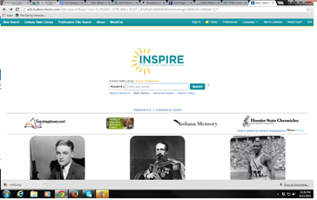

Scroll down and click Student Research Center to access the database.
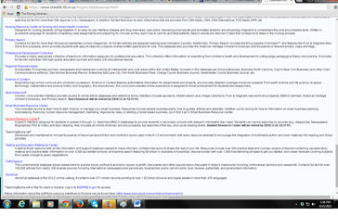
Search for your information.
